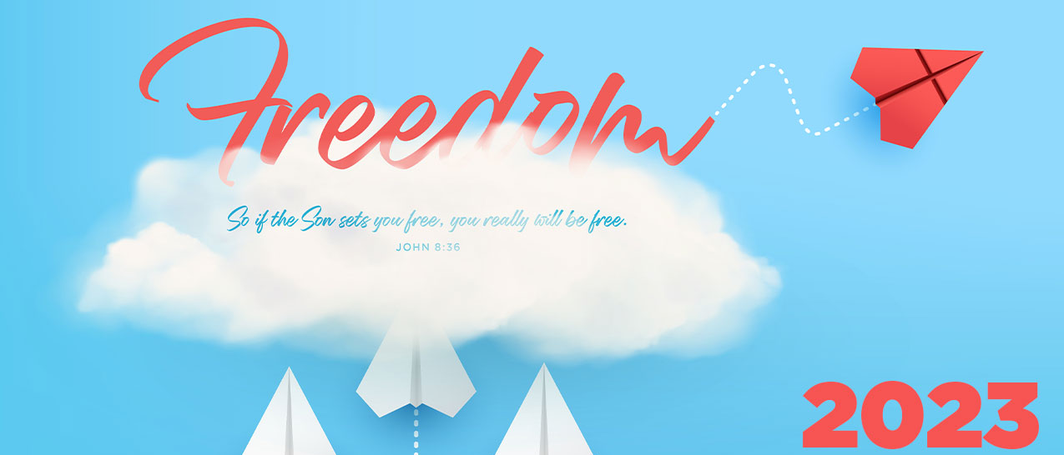

What is the purpose? Journey Camp is a fun-filled, energetic camp designed to engage elementary age kids in age-appropriate worship, Bible study, recreation, track times, and other exciting camp activities. Journey Camp is grounded in scripture and is intentionally gospel centered. Our desire is to see kids experience God in such a way that it will impact their journey of faith for a lifetime.
- When is it? June 9th - 11th

- Where is it? Linden Valley Conference Center, 1225 Baptist Camp Road, Linden, TN 37096

- Who can go? Children that have finished 2nd grade through 5th grade can attend.

- How much does it cost? The cost per child will be $150. The cost will be broken into three manageable payments. Deposits will not be refundable after May 1st.

  - February 19th- $50.00
  - April 2nd- $50.00
  - May 7th- $50.00

- What does the cost cover? The cost will cover the following; transportation, camp, meals during camp, t-shirt, and activities. Children will need money for two travel meals (max of $10 per meal).

- What is needed? A packing list is attached to back of packet.

- How many leaders? Parents are allowed to attend camp with their child, the cost per adult is $100. All adult leaders must complete a background check before May 1st.

- How do I sign-up? Sign-up is online based only. Online registration is currently not open. We will inform you and send helpful hints to sign-up.

- Want more information?
  - Visit: https://tnbaptistcamps.org/journey-camps/
  - Contact: Jacob Medlock, Family Pastor- (662) 507-1508

